PROJECT REPORT
ML-Powered Scrap Trading Platform
Submitted in partial fulfilment of the requirement for the award of the degree of

BACHELOR OF TECHNOLOGY
IN
COMPUTER SCIENCE & ENGINEERING
Submitted by
Akshit Garg University Roll No- 2218293
Akhil Nautiyal University Roll No- 2218273
Nitin Rawat University Roll No- 2219187
Under the guidance of
Dr. Prateek Srivastava
Assistant Professor,
Project Group No: 150

Department of Computer Science and Engineering
Graphic Era Hill University, Dehradun
May, 2026



CANDIDATE’S DECLARATION
I/We hereby certify that the work which is being presented in the project progress report entitled “ML-Powered Scrap Trading Platform” in partial fulfillment of the requirements for the award of the Degree of Bachelor of Technology in Computer Science and Engineering in the Department of Computer Science and Engineering of the Graphic Era Hill University, Dehradun shall be carried out by the undersigned under the supervision of Dr. Prateek Srivastava, Asst. Prof., Department of Computer Science and Engineering, Graphic Era Hill University, Dehradun.

Akshit Garg University Roll No- 2218293
Akhil Nautiyal University Roll No- 2218273
Nitin Rawat University Roll No- 2219187 signature

ACKNOWLEDGEMENT

I would like to express my sincere gratitude to my project guide, Dr. Prateek Srivastava, for his continuous guidance, support, and encouragement throughout the development of this project.
I also thank the Department of Computer Science & Engineering, Graphic Era Hill University, for providing the necessary resources and environment to successfully complete this project.
Finally, I extend my gratitude to my team members for their collaboration and contribution.

Akshit Garg Akhil Nautiyal Nitin Rawat
2218293 2218273 2219187
ABSTRACT

The ML Powered Scrap Trading Platform is an intelligent web-based marketplace designed to improve the buying and selling of second-hand goods using machine learning techniques. The platform integrates features such as image-based product search, price prediction, counterfeit detection, and personalized recommendations.
It utilizes technologies like ReactJS, Flask, Firebase, and machine learning models such as MobileNetV2 and Random Forest to enhance user experience and ensure secure transactions. The system aims to reduce pricing uncertainty, prevent fraud, and promote sustainable consumption by enabling efficient reuse of goods.
This project contributes to building a smart and trustworthy digital ecosystem for the circular economy.
TABLE OF CONTENTS

ACKNOWLEDGEMENT i
ABSTRACT ii
LIST OF TABLES iv
LIST OF FIGURES v
ABBREVIATIONS vi
NOTATIONS vii

INTRODUCTION 1

MS Word features………………………………….……………….................... 2

MS Word figures……………………………………………………………….. 2

MS Word options………………………………………………………………. . 2

REQUIREMENT ANALYSIS
2.1----

A SAMPLE APPENDIX 3
LIST OF TABLES
Sno. | Table Description / Caption | Page No

LIST OF FIGURES

Sno. | Figure Description / Caption | Page No

ABBREVIATIONS

GEHU Graphic Era Hill University
HTML Hyper Text Markup Language
NOTATIONS

α Scale parameter
β Depth angle in degrees

CHAPTER 1

INTRODUCTION AND MOTIVATION

  - Introduction

- The ML Powered Scrap Trading Platform is an intelligent web-based marketplace designed to simplify and enhance the buying and selling of second-hand and scrap goods.
- Traditional resale platforms rely heavily on manual processes, subjective pricing, and text-based search, which often leads to inefficiency and poor user experience.
- This project integrates machine learning techniques to automate key functionalities such as product discovery, price estimation, authenticity verification, and personalized recommendations.
- The platform enables users to upload product images, receive fair price suggestions, and detect counterfeit items, making the trading process more transparent and reliable.
- The system is developed using modern technologies such as:
  - ReactJS (Frontend)
  - Flask (Backend)
  - Firebase (Database & Authentication)
  - Machine Learning models (MobileNetV2, Random Forest, CNN)
- The overall aim is to create a smart, secure, and scalable ecosystem for second-hand product trading.

1.2 Background
- The rapid growth of e-commerce has increased the demand for second-hand and resale platforms.
- However, existing platforms suffer from several limitations:
  - Lack of fair pricing mechanisms
  - Difficulty in verifying product authenticity
  - Inefficient search systems
  - Limited personalization
- Machine Learning has shown strong potential in solving these problems through:
  - Image recognition
  - Predictive analytics
  - Recommendation systems
- This project leverages these technologies to build an AI-driven resale platform.

  - Problem in Existing Systems
- Current second-hand marketplaces face multiple challenges:
  - Pricing Uncertainty
    - Sellers often set arbitrary prices
    - Buyers lack trust in pricing fairness
  - Counterfeit Products
    - Fake branded items are common
    - No reliable verification system
  - Inefficient Search
    - Text-based search fails when users only have images
  - Poor User Experience
    - Lack of smart recommendations
    - Low engagement
  - Environmental Impact
    - Reusable items are wasted due to inefficient resale systems

1.4 Motivation
- The motivation behind this project is to solve real-world problems in resale markets using technology.
- Key motivating factors:
  - To automate price prediction using machine learning
  - To enable image-based search for better product discovery
  - To detect counterfeit products using deep learning
  - To improve user engagement through recommendations
  - To build trust and transparency in online transactions
  - To promote sustainability and circular economy
- The project aims to bridge the gap between traditional resale systems and modern intelligent platforms.

1.5 Scope of the Project
- The system focuses on:
  - Buying and selling second-hand goods
  - Smart product search using images
  - Automated price estimation
  - Fraud detection through logo verification
  - Personalized product recommendations
- The platform can be extended in future to:
  - Mobile applications
  - Real-time bidding systems
  - Blockchain-based transaction security

1.6 Organization of the Report
- The report is structured as follows:
  - Chapter 1: Introduction and motivation
  - Chapter 2: Objectives and problem statement
  - Chapter 3: Software and hardware requirements
  - Chapter 4: Methodology and system design
  - Chapter 5: Implementation and results
  - Chapter 6: Conclusion and future scope

CHAPTER 2

OBJECTIVES OR PROBLEM STATEMENT

2.1 Problem Statement
- The rapid growth of online resale platforms has created opportunities for trading second-hand goods, but several critical challenges still exist.
- Existing systems lack intelligence, automation, and trust mechanisms, which results in inefficient transactions and poor user experience.
- The key problems identified are:
  - Subjective Pricing
    - Sellers set prices based on guesswork
    - Buyers find it difficult to judge fair value
    - Leads to long negotiations and mistrust
  - Counterfeit Products
    - Fake branded items are frequently listed
    - No reliable system to verify authenticity
    - Increases fraud risk
  - Inefficient Product Search
    - Text-based search is limited
    - Users cannot search using images
    - Difficulty in finding similar products
  - Lack of Personalization
    - No intelligent recommendation system
    - Users are not shown relevant products
    - Low engagement and retention
  - Security Issues
    - Weak authentication systems
    - Risk of unauthorized access and fraud
  - Environmental Concerns
    - Reusable items often go to waste
    - Lack of efficient resale ecosystem
- Therefore, there is a need for an intelligent, secure, and automated platform that improves trust, efficiency, and sustainability in the resale market.

2.2 Objectives of the Project
- The primary objective of this project is to develop an ML-powered web platform for buying and selling second-hand goods with enhanced intelligence and security.

- Core Objectives
  - To design and develop a scalable web-based resale platform
  - To provide a user-friendly interface for seamless interaction
  - To ensure secure and reliable transactions

- Machine Learning Objectives
  - To implement Image-Based Product Search
    - Using MobileNetV2
    - Enables users to search products via images
  - To implement Price Prediction System
    - Using Random Forest (baseline model)
    - Can be enhanced with XGBoost for higher accuracy
    - Provides fair and data-driven pricing
  - To implement Logo Verification System
    - Using CNN (Convolutional Neural Network)
    - Detects fake vs genuine branded products
  - To implement Recommendation System
    - Using TF-IDF and Cosine Similarity
    - Provides personalized product suggestions

- Security Objectives
  - To implement secure user authentication
    - Using Firebase Authentication
  - To ensure data protection and API security
    - Using secure tokens (JWT/API keys)

- System Objectives
  - To integrate frontend, backend, and ML models efficiently
  - To ensure smooth communication between components
  - To maintain real-time data handling using Firebase

- User Experience Objectives
  - To design a responsive UI using ReactJS and Tailwind CSS
  - To provide:
    - Easy navigation
    - Fast search
    - Advanced filtering options

- Sustainability Objective
  - To promote reuse and recycling of goods
  - To support the circular economy
  - To reduce environmental waste through efficient resale

2.3 Summary
- This project aims to solve real-world problems in second-hand marketplaces by integrating machine learning, modern web technologies, and secure systems.
- The objectives focus on:
  - Improving trust
  - Automating processes
  - Enhancing user experience
  - Promoting sustainability

CHAPTER 3

SOFTWARE AND HARDWARE REQUIREMENTS

3.1 Introduction
- This chapter describes the technical requirements and system specifications needed to develop and run the ML Powered Scrap Trading Platform.
- It includes:
  - Software requirements
  - Hardware requirements
  - System requirements specification (SRS)
  - Basic system architecture

  - Software Requirements
- Development Technologies
  - Frontend
    - ReactJS
    - Tailwind CSS
  - Backend
    - Flask (Python)
  - Database & Authentication
    - Firebase Realtime Database
    - Firebase Authentication

- Machine Learning Libraries
  - TensorFlow / Keras
  - Scikit-learn
  - NumPy, Pandas

- NLP & Recommendation
  - TF-IDF Vectorization
  - Cosine Similarity

- Development Tools
  - Visual Studio Code
  - GitHub (Version Control)
  - Postman (API Testing)

- Operating System
  - Windows / Linux / macOS

  - Hardware Requirements
- Minimum Requirements
  - Processor: Intel i5 or equivalent
  - RAM: 8 GB
  - Storage: 256 GB SSD
  - Internet connection

- Recommended Requirements
  - Processor: Intel i7 or higher
  - RAM: 16 GB
  - GPU (optional for ML training)
  - High-speed internet

3.4 System Requirements Specification (SRS)
3.4.1 Functional Requirements
  - The system should allow user registration and login
  - The system should allow product listing with images
  - The system should support image-based search
  - The system should provide price prediction
  - The system should perform logo verification (fake detection)
  - The system should provide personalized recommendations
  - The system should allow secure transactions and data handling

3.4.2 Non-Functional Requirements
  - Performance : Fast response time for search and predictions
  - Scalability : System should handle multiple users simultaneously
  - Security : Secure authentication and API communication
  - Usability : Simple and user-friendly interface
  - Reliability : System should work without frequent failures

    - User Requirements
- Users should be able to:
    - Register and login securely
    - Upload product images
    - View predicted price
    - Search products using images
    - Get recommendations

3.4.4 System Requirements
- The system must:
  - Integrate frontend, backend, and ML models
  - Store and retrieve data efficiently
  - Process image and text data

  - System Architecture
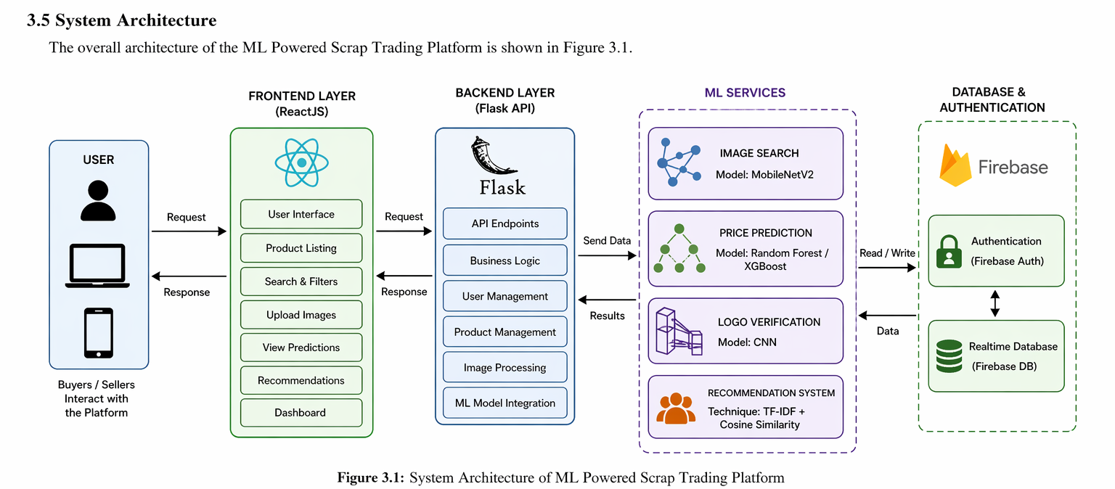

3.6 Summary
- This chapter defined the technical foundation of the project.
- It covered:
  - Required software tools
  - Hardware specifications
  - Functional and non-functional requirements
  - Overall system architecture
- These requirements ensure that the system is scalable, secure, and efficient.

CHAPTER 4

project methodology / design

( Algo and blue print should be included in this chapter with proper diagram)
This section may include architectural design of the project, implementation of any objectives, pseudo code/ algorithms, discussion of the results, etc.

CHAPTER 5

IMPLEMENTATION and results

The new paragraph can start in the next line, with no gap. There is an indentation of 0.2” at the beginning of the paragraph. Paragraph in the thesis will always be justified, not left-centered.

CHAPTER 6

Conclusion AND fUTURE SCOpe

The new paragraph can start in the next line, with no gap. There is an indentation of 0.2” at the beginning of the paragraph. Paragraph in the thesis will always be justified, not left-centered.

References
[1] Ji, XunSheng, et al. "Application of the digital signal procession in the MEMS gyroscope de-drift." Nano/Micro Engineered and Molecular Systems, 2006. NEMS'06. 1st IEEE International Conference on. IEEE, 2006.
[2] Nussbaumer, Henri J., and Martin Vetterli. "Computationally efficient QMF filter banks." Acoustics, Speech, and Signal Processing, IEEE International Conference on ICASSP'84.. Vol. 9. IEEE, 1984.
Sites those you used

Any other reference

List of Publications
(if any)
- Ji, XunSheng, et al. "Application of the digital signal procession in the MEMS gyroscope de-drift." Nano/Micro Engineered and Molecular Systems, 2006. NEMS'06. 1st IEEE International Conference on. IEEE, 2006.

APPENDIX A
(Code)

It will contain code of project/software.

